**Practical 5 – Design your own experiment**

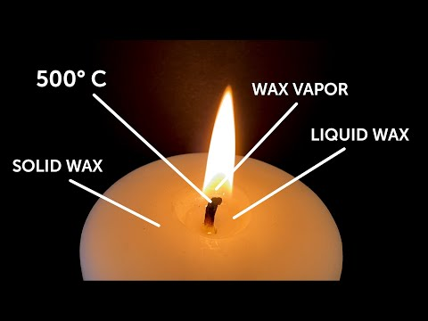***Reburning of Candle***

|  |  |
| --- | --- |
| **Team Member’s names and roll nos.** | **Omkar Patil : 21102A0003**  **Premanshu Chaudhari : 21102A0016**  **Deep Salunkhe : 21102A0014**  **Pranav Redij : 21102A0005**  **Mayur Hile : 21102A0017** |
| **Title** | **Reburning candle using its fumes** |
| **Video link** |  |
| **Procedure** | **1.Light the candle let it burn for few minutes** **2.Now extinguish the flame and take a liter near its smoke** |
| **Observations** | **The flame is carried by the smoke(fumes) and the candle is reignited** |
| **Take aways of the activity** | **1.As wax is s higher hydrocarbon while combustion it partially combusted and the byproduct formed is lower hydrocarbons which is passed via fumes**  **2.As the flash point of lower hydrocarbon is lower when we take flame near it , it catches fire and it is transferred to the candle** |
| **Snapshot** |  |

: